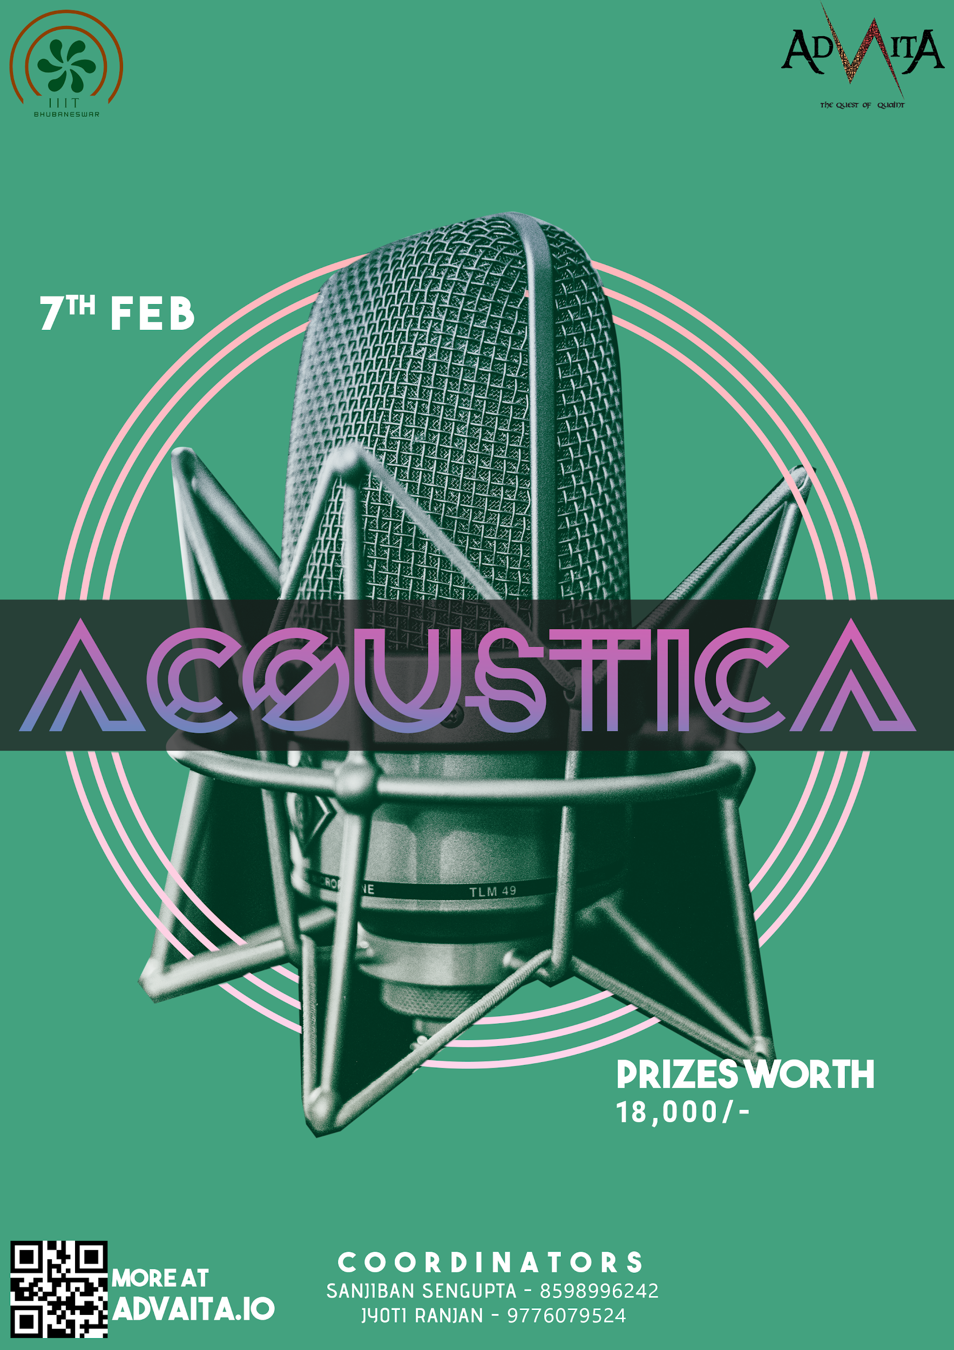

**ACOUSTICA**

The Quest for the sensation, for the esteemed manifesting the excellence of music, Advaita’20 brings **Acoustica** - giving a stage for portraying, the most unique and tranquil music. The essential literature of heart creating the melodies of mind, Music has always left us spellbound by its astounding expression of thoughts in the rhythms of harmony. So, to unfold a magical spell and make the charm of music more captivating, this is a call to all the singers out there, to come up in solo, duet or groups and grace us with your alluring music and express and explore your depths so that it knows no bounds.

**Event has categories:** Solo, Group

Registration Fees:

1. **Solo : 300/-**
2. **Group : 200/- per participant (if total participants is less than 5)**

**1200/- ( if total participants is more than 5)**

Prizes worth : 18,000/-

Date : 7th Feb

Venue: Second Stage, IIIT Campus

Instruments Allowed :

* **Acoustic Guitar**
* **Keyboard (Only in the Grand Piano Patch)**
* **Ukulele**
* **Tabla**
* **Sitar**
* **Harmonica**
* **Violin**
* **Melodica**
* **Cello**
* **Mandolin**
* **Flute**

### **Cajón**

* **Bass Guitar (Only in clean tone)**

**RULES**

SOLO

1. **Every candidate should bring their own Karaoke tracks.**
2. **There will be no language restrictions for the participants.**
3. **Time Limit - 4 minutes. (including sound check)**
4. **Any material after the time limit will be considered as invalid.**

GROUP

1. **Each group must consist of 2-7 members.**
2. **There will be no language restrictions for the participants.**
3. **No pre-recorded music is allowed.**
4. **Time Limit : 8 minutes. (including sound check)**
5. **Any material after the time limit will be considered as invalid.**

**JUDGING CRITERIA**

* **Synchronization and instrument performance : 20 points.**
* **Stage Presence : 10 points.**
* **Vocals : 20 points.**
* **Audience Reaction: 10 points.**
* **Professionalism : 10 points.**
* **Originality : 30 points.**

**AWARD CATEGORIES**

* **Best Group (First and Second)**
* **Best Solo (Winner)**

**NOTE:** Drum-Kit and Mics will be provided at the venue.